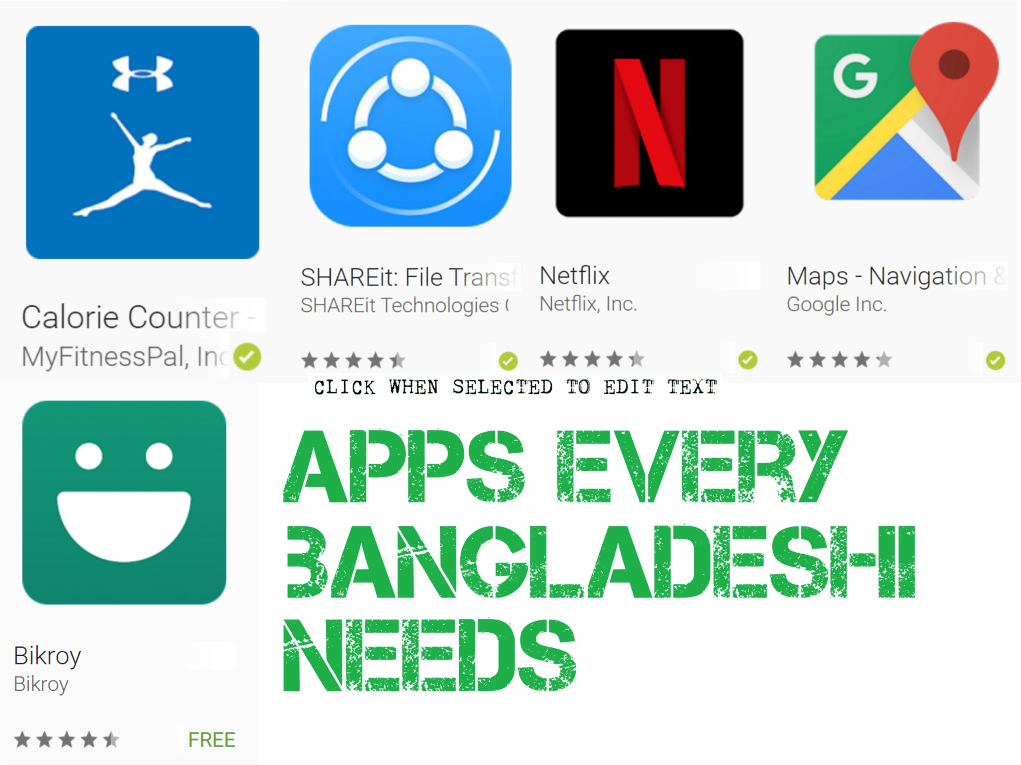
Google Maps

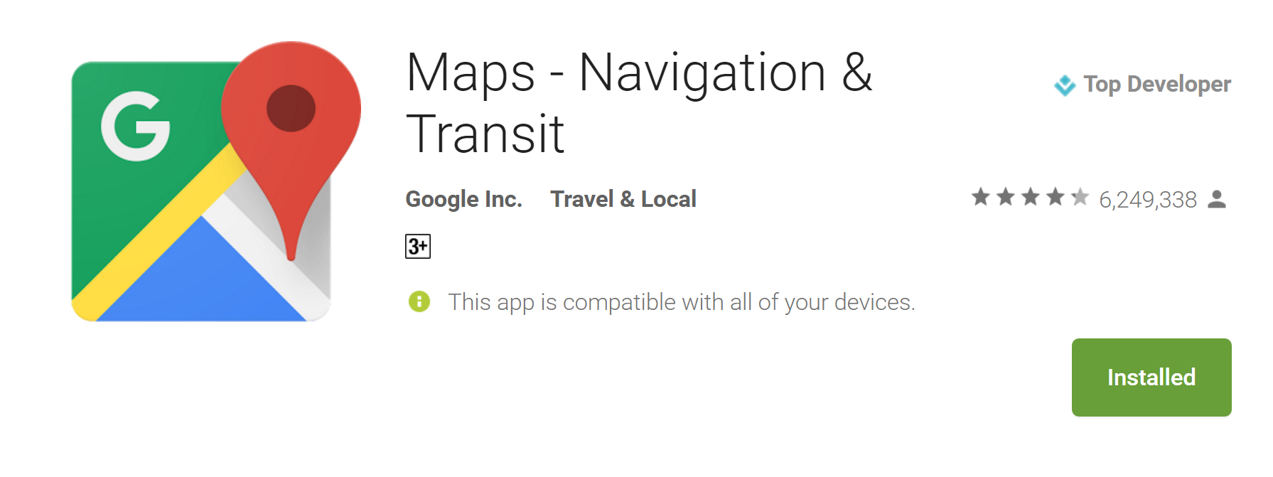
Navigating the country is seriously difficult. Half the time there are no signs marking the road numbers and the signs that are still standing are usually illegible or even covered in posters. Google Maps over the years has evolved to become an indispensable resource with relatively accurate layouts of the major cities and even the countryside. It is by no means perfect but it is one of the most convenient and reliable methods to navigate the country (just stop and ask for directions if/when you get lost)

Bikroy
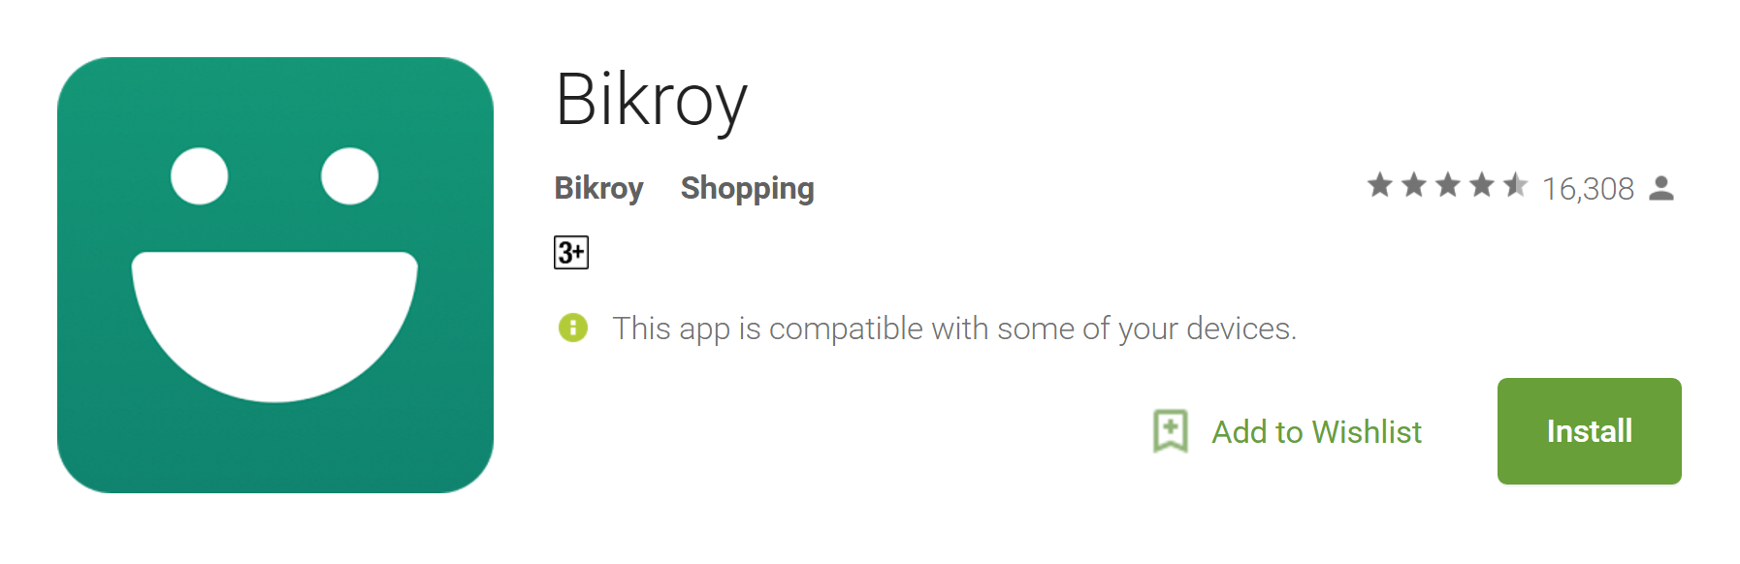

The Bikroy app is a platform where users can buy and sell almost anything through advertising and is now super convenient with the new “Buy Now” feature. It allows you to easily make purchases and have your order delivered to your doorstep (currently available in Dhaka and its suburbs only). The app supports English and Bangla languages and so is easily accessible to all. The app can be used to save favourite ads for later reference and is also the tool used to manage ads you yourself post.

Netflix

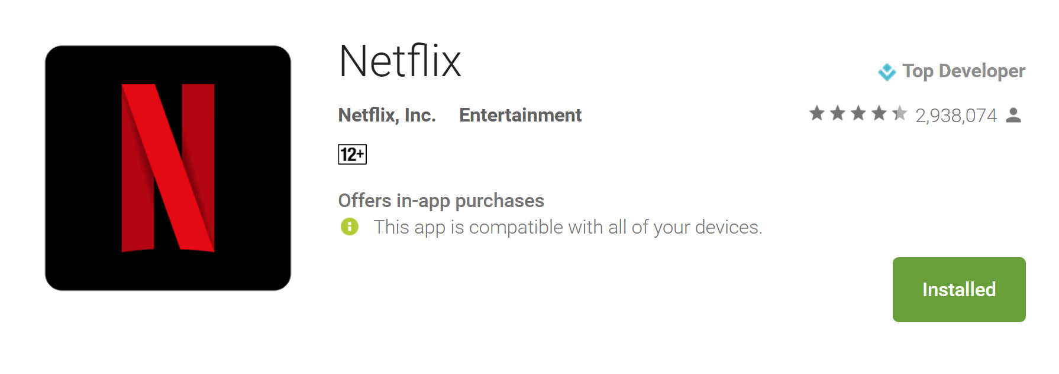
Piracy is a big problem in Bangladesh and honestly speaking, the public cannot be blamed for it as there are few (if any) official outlets for media consumption. The launch of Netflix in Bangladesh earlier this year was the beginning of countering this trend. The service lets you stream a diverse library of movies and TV shows using the internet. It is free for the first month and USD 9.99 after.

SHAREit

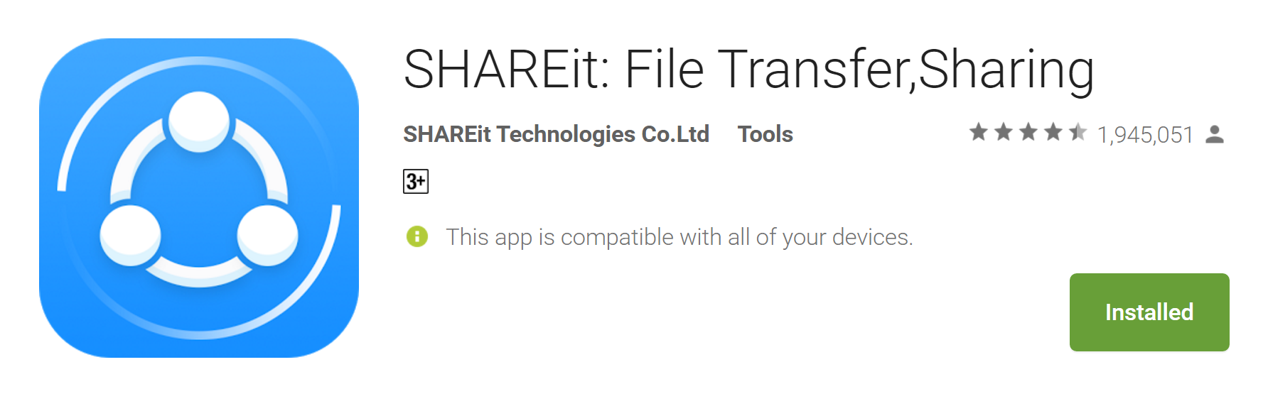
If you are using an iPhone or iPad, you’ll know very well that there is no native means of transferring files between Android and iOS devices. SHAREit is therefore an absolutely necessary tool which uses WiFi Direct to transfer files like images, videos and documents between devices at considerably fast speeds.

Calorie counter-My Fitness Pal

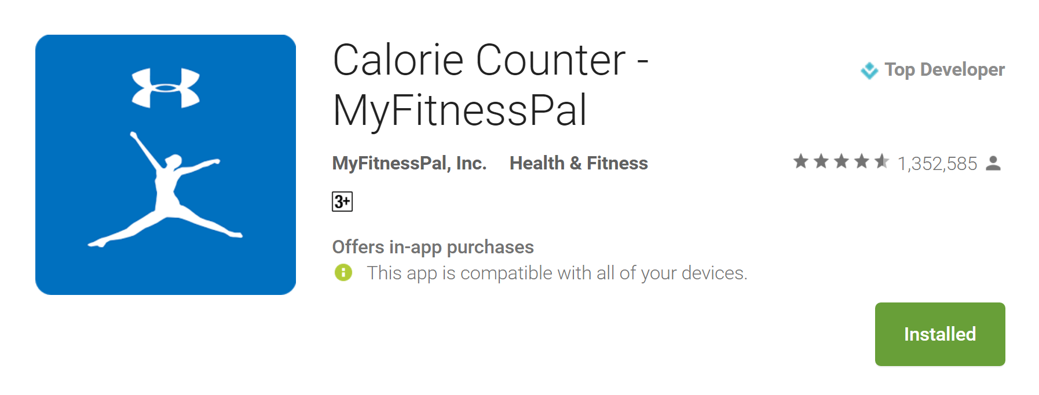
Our health is our most valuable asset and this app allows you to record your food intake and also estimate the calories consumed from them. A barcode scanner is built into the app and is used to quickly get information about packaged food products. For items not found in the diverse food library, you can even create your own recipes from raw ingredients and estimate their nutritional values.

